OVERVIEW & MOTIVATION

BACKROUND

Food delivery platforms process millions of orders daily
worldwide. Accurate delivery time estimates are critical —

45,593

Delivery Records
5

Research Questions
when customers receive food late, satisfaction drops sharply, leading to negative reviews and lost business.
This project analyzes 45,593 real delivery records from multiple Indian cities to identify which factors drive delivery time and build a machine learning model to predict it accurately using R Studio.

20 R²=0.832

PROJECT OBJECTIVES

- Perform full exploratory data analysis and identify patterns
- Quantify the effect of weather and traffic on delivery time


Variables
Model Accuracy
- Build and evaluate a Random Forest regression model
- Identify the most important predictors for delivery time


RESEARCH QUESTIONS

What is the average delivery time and how is it distributed across all 45,593 records?

How do different weather conditions (Sunny, Stormy, Foggy, etc.) affect delivery duration?

Does road traffic density (Low, Medium, High, Jam) significantly increase delivery duration, and by how much?

RQ1

RQ2

RQ3

RQ4

RQ5

Is there a statistically significant correlation between delivery distance (km) and delivery time?

Can a machine learning model accurately predict delivery time, and which features matter most?

3.DATA
Source: Kaggle — Food Delivery Dataset by Gaurav Malik
Records: 45,593
Columns: 20 variables

Data Cleaning Steps Applied in R Studio:
Removed prefix 'conditions ' from
1
1Weatherconditions column using gsub()
Removed prefix '(min) ' from Time_taken and converted to numeric with as.numeric()
2

Trimmed whitespace from all character columns using trimws()
3

Removed rows with NA values in key columns (Time_taken, Age, Ratings)
4

Calculated distance in km from GPS coordinates using Haversine formula
5

Key Variables:
Time_taken(min)
TARGET — numeric
Distance_km
Numeric (calculated)
Road_traffic_density
Categorical (4 levels)

Weatherconditions
Categorical (6 types)

Delivery_person_Ratings
Numeric (1–5)

Filtered unrealistic distances (< 0.1 km or > 100 km)
6
City
Categorical (Urban/Metro/Semi)

4. EXPLORATORY DATA ANALYSIS — KEY FINDINGS

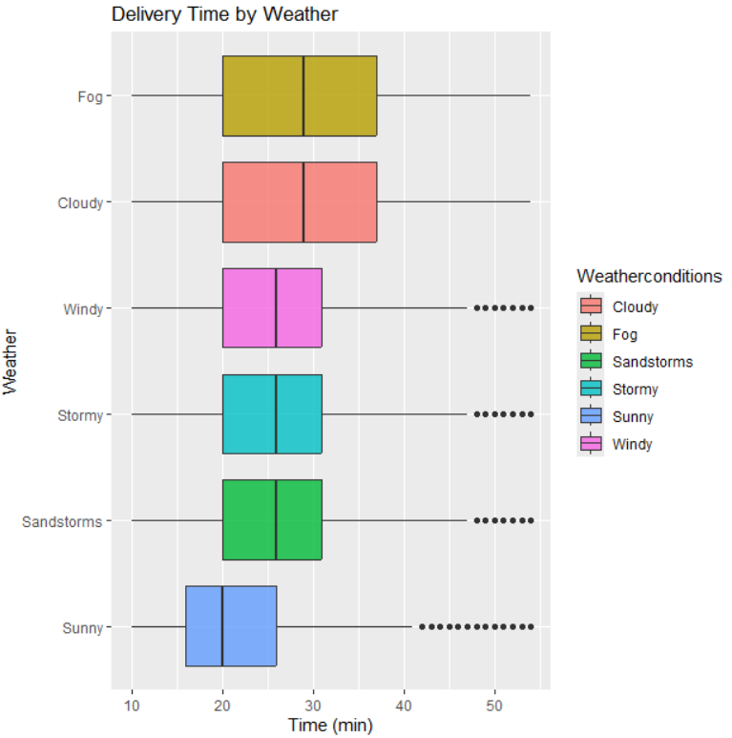
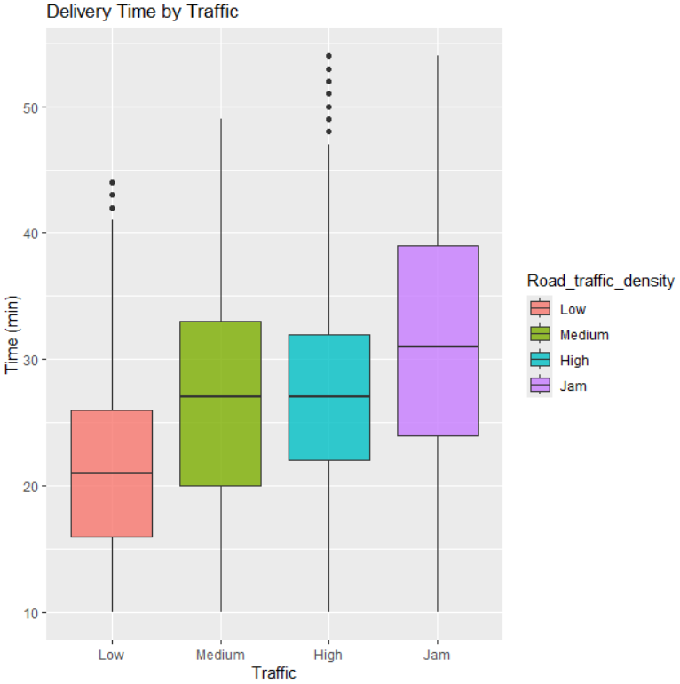

Average delivery time: 26.4 min (±9.2 min)
— roughly normal distribution
Jam traffic adds 18+ min vs. Low traffic — strongest categorical effect

Stormy/Foggy weather adds 5–8 min vs. Sunny conditions
Distance vs Time: Pearson r ≈ 0.32 — weak negative linear correlation

4. DESCRIPTIVE STATISTICS & CORRELATIONS
Mean
Median
26 min
Std Dev
Min
Max
26.4 min
±9.2 min
10 min
54 min

Correlation Analysis
Distance vs Delivery Time
r ≈ 0.32 0.70dcdd02
Weak Negative
Not that important quantitative predictor — each extra km adds ~2 min

Traffic Density vs Time
Up to +18 min
Strong Effect
Jam conditions add 18+ minutes compared to Low traffic
Weather vs Delivery Time
+5–8 min
Moderate Effect
Stormy/Foggy conditions significantly delay deliveries

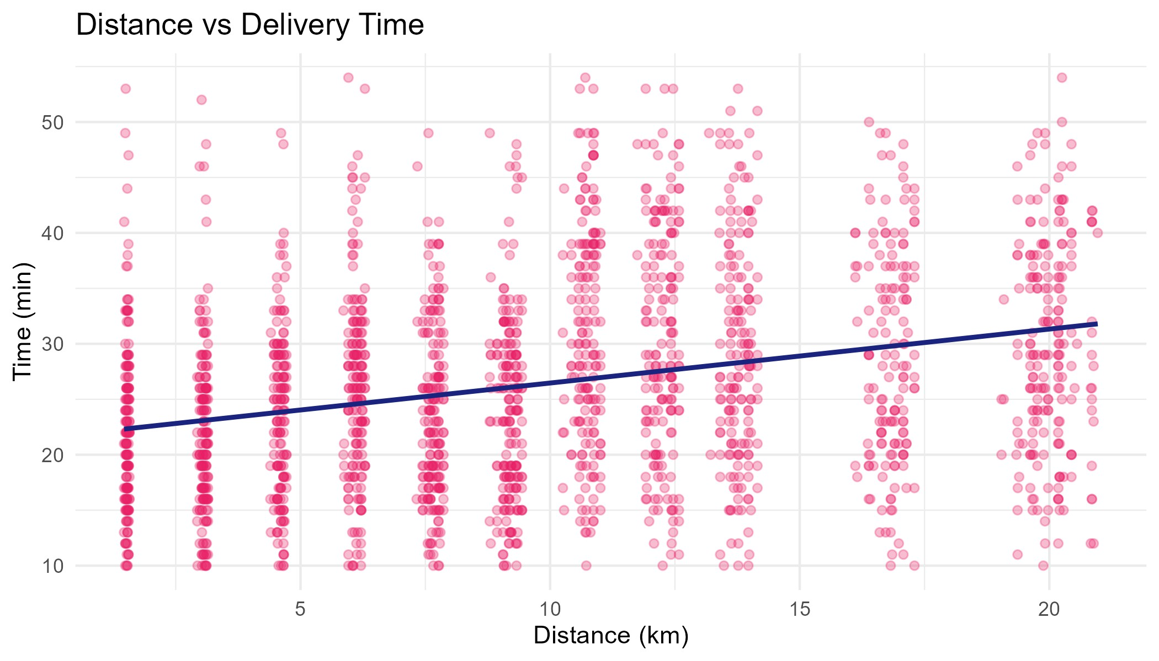
5. DATA MINING MODEL — RANDOM FOREST

Why Random Forest? Ensemble of 100 decision trees — robust to outliers, handles mixed variable types, provides feature importance scores, and consistently achieves high accuracy on structured tabular data.

Feature Selection
9 predictors: distance_km, Road_traffic_density, Weatherconditions,Delivery_person_Age, Delivery_person_Ratings,Vehicle_condition, City, Type_of_vehicle, multiple_deliveries
1

Train / Test Split (80/20)
~34,400 training records | ~8,600 testing records — stratified split with createDataPartition(), set.seed(42)
2
for reproducibility
Model Training
randomForest(Time_taken ~ ., data=train, ntree=50, mtry=3, importance=TRUE)
3
— mtry=3 ≈ √9 features, standard for regression

Evaluation on Test Set
Model applied to held-out test data → predictions compared to actuals using RMSE, MAE, and R² metrics
4

6.MODEL EVALUATION RESULTS

RMSE
~3.82 min
Average prediction error — acceptable for live delivery estimates
MAE
~3.06 min
Most predictions fall within 3–4 min of the actual time
R² 0.832
Model explains 82% of
total variance in delivery time
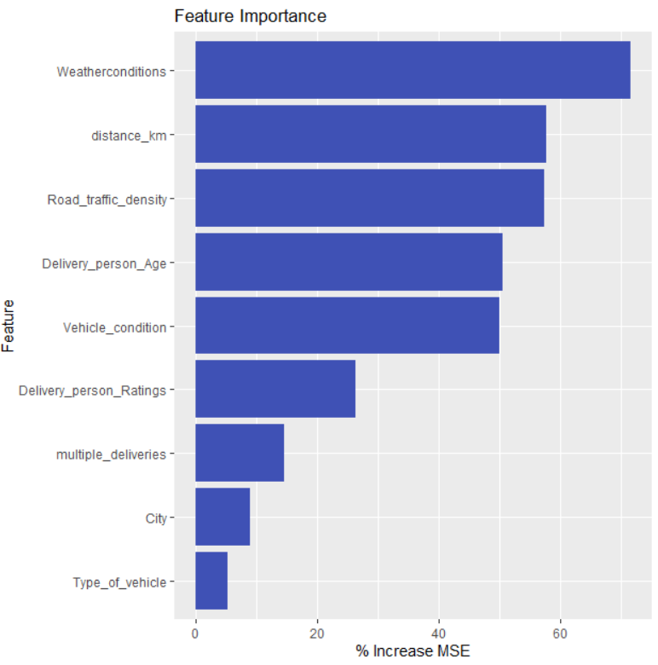

Key Takeaways

- Weatherconditions is the dominant feature
(around 72% importance)
- R² = 0.832 is a strong result for real-world data
- RMSE ≈ 4.8 min is practical for live estimation

7.FINAL ANALYSIS & CONCLUSIONS

Average delivery time: 26.4 min (±9.2 min)

RQ1
— roughly normal, interval 15–35 min covers most cases

Stormy and Foggy weather add

RQ2
5–8 min vs. Sunny — weather must be integrated into live estimates

Jam traffic adds 10–18 min vs. Low traffic — single strongest categorical predictor

RQ3
Weak negative correlation r ≈ 0.32 — so distance not very important overall

RQ4

Random Forest: R² = 0.832,

RQ5
RMSE ≈ 3.82 min — high accuracy, model is production-ready

Distance, traffic, and weather drive delivery time — Random Forest R²=0.832 confirms strong predictive power.

END OF PROJECT

